**THE UNIVERSITY OF BUEA** **REPUBLIC OF CAMEROON**

P.O Box 63, PEACE-WORK-FATHERLAND

Buea, Southwest Region

Cameroon

Tel: (237) 674354327

Fax: (237) 3332 22 72

**FACULTY OF ENGINEERING AND TECHNOLOGY**

**DEPARTMENT OF COMPUTER ENGINEERING**

**CEF 440: Internet programming and mobile programming**

**Design and Implementation of a Road Sign and Road State Mobile Notification Application**

Group 15

**TASK 3: UI Design and Implementation**

[GitHub - Asumu22/group-15](https://github.com/Asumu22/group-15)

<https://www.figma.com/design/Qk0rRSDJMGu4xmreSQygLA/RoadGuard?node-id=0-1&t=9nFD8sr3nFZS3M6a-1>

|  |  |  |  |
| --- | --- | --- | --- |
| No | Name | Matriculation No | Specialty |
| 01 | KONGNYUY RAYMOND AFONI | FE21A219 | NE |
| 02 | BESONG ELIAS ASUMU | FE21A149 | SE |
| 03 | KANKO KEMEDJEU DUPLEX | FE21A210 | NE |
| 04 | KENEDY MALLEY ITUKA | FE21A212 | NE |
| 05 | AZEFACK JUNIOR | FE21A146 | NE |

**Dr. NKEMENI Valery**

**Course Supervisors 2023 - 2024 Academic Year**

Abstract

This document presents the UI design and implementation plan for a mobile application that assists drivers with real-time road sign recognition and road state information. The design prioritizes a user-friendly experience, leveraging Human-Computer Interaction (HCI) principles and Service-Oriented Architecture (SOA) for usability and scalability. Detailed layouts with field descriptions and interaction details are provided for each screen.

Table of content

Introduction 4

Design Principles 4

Human-Computer Interaction (HCI) 4

Service-Oriented Architecture (SOA) 4

UI Design Process 4

Tools and Frameworks used 4

Wireframes and Mockups 5

User Flows 5

Detailed UI Layouts 5

FIrst screen (splash screen) 5

ONBOARDING SCREEN 5

SIGN IN Screen 6

reset PASSWORD screen 6

Sign-Up Screen 8

Home Screen (As slider) 8

Navigation Screen 9

Real-Time Sign Recognition Screen 10

User Reporting screen 10

User feedback screen 11

Settings Screen 12

User Profile Screen 12

Help center screen 13

Implementation Plan 14

Frontend Technologies 14

Conclusion 14

**SYSTEM MODELING AND DESIGN for Road Sign and Road State Mobile Notification Application.**

## Introduction

This task focuses on designing a user interface (UI) for the Road Sign and Road State Mobile Notification Application. The goal is to create an intuitive and accessible UI that enhances user interaction and experience. HCI principles and SOA will guide the design to ensure modularity, scalability, and user satisfaction.

## Design Principles

### Human-Computer Interaction (HCI)

* Usability: The application should be easy to use and understand for users with varying levels of technical expertise.
* Accessibility: The design should consider users with disabilities, including visual impairments.

Here we input provide voice output ability.

* Feedback: The application should provide immediate and clear feedback for user actions.

Our application interface provide section for user feedback.

* Consistency: A consistent look and feel should be maintained throughout the application.
* Minimize Cognitive Load: The UI should be simplified to reduce the amount of mental effort required for users.

### Service-Oriented Architecture (SOA)

* Modularity: The application should be broken down into independent modules for easier development, testing, and maintenance.
* Scalability: The UI should be designed to accommodate future features and increased user load.
* Reusability: Common UI components should be used across different parts of the application.
* Interoperability: The application should be designed to integrate with other systems and services.

## UI Design Process

### Tools and Frameworks used

* Figma: For wireframing and creating high-fidelity mockups.(LINK FOR OUR FIGMA DESIGN)

<https://www.figma.com/design/Qk0rRSDJMGu4xmreSQygLA/RoadGuard?node-id=0-1&t=9nFD8sr3nFZS3M6a-1>

* React Native: For building the mobile application.

### Wireframes and Mockups

Wireframes provide a skeletal framework of the application, while mockups offer a high-fidelity visual representation.

### User Flows

User flows outline the path users take to navigate through the application, ensuring a smooth and logical progression from one screen to another.

## Detailed UI Layouts

### FIrst screen (splash screen)

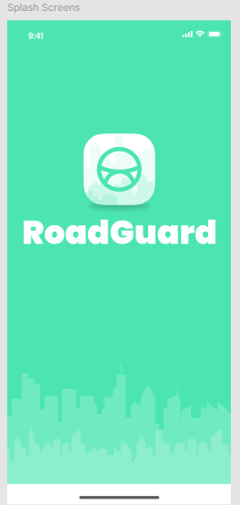Purpose: Simply Introduce the app name and logo.

### ONBOARDING SCREEN

Purpose: Gives the user an abstract view of the main application functionality.

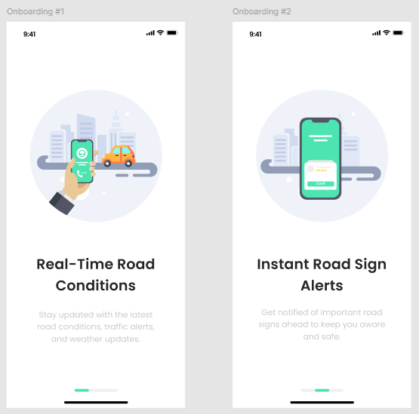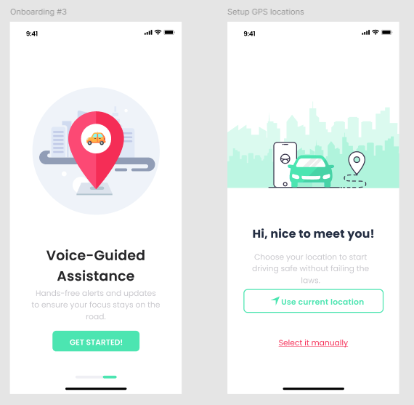

### SIGN IN Screen

Purpose: Allows existing users to log in to the application.

Components:

* Phone number
* Password Field
* Login Button (Next)
* Forgot Password Link
* Sign-Up Link
* Login with Gmail option button

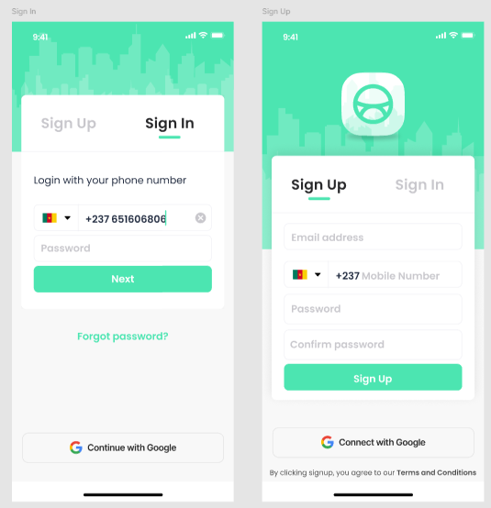

### reset PASSWORD screen

Purpose: User recovers password incase he forgets when loginning in.

Components:

* Email field: To request new password.
* Reset Password Button
* Reset password code

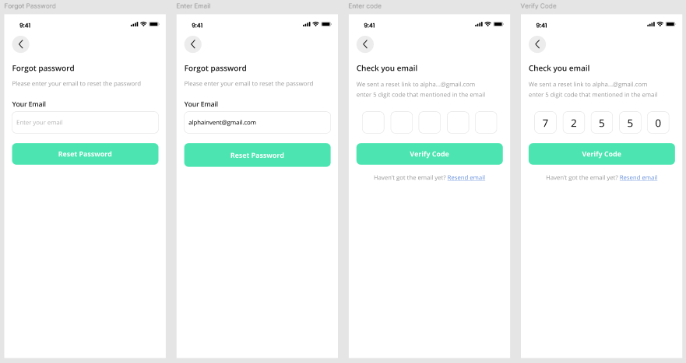

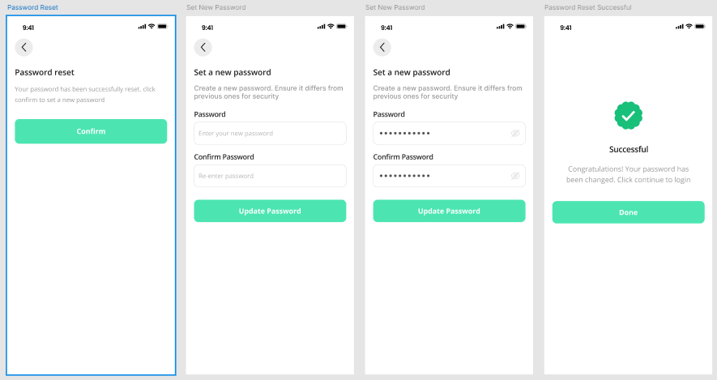

### Sign-Up Screen

Purpose: Allows new users to create an account.

Components:

* Username Field: Accepts a unique username.
* Email Field: Accepts a valid email address.
* Password Field: Accepts a password (masked input).
* Confirm Password Field: Accepts password confirmation

(masked input).

* Sign-Up Button: Submits the registration form and takes you
* to login page
* Login Link: Redirects to the login screen.



### Home Screen (As slider)

Purpose: Provides an overview and quick access to key features.

With a slider containing

Components:

* Navigation Bar: Links to Home, Map, Alerts, Profile
* Current Location Display
* Quick Access Buttons: Start Navigation, View Alerts
* 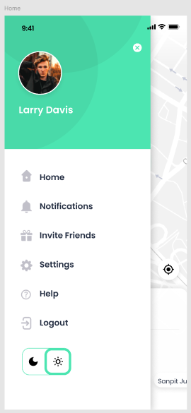Home
* Notifications
* Invite Friends
* Settings
* Help
* Logout link

### Navigation Screen

Purpose: Provides navigation assistance with real-time updates.

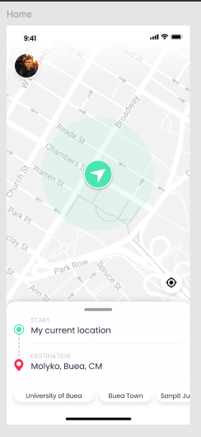Components:

* Map Display: Shows the user's current route and destination.
* Turn-by-Turn Directions: Provides clear instructions for navigating

to the destination.

* AR Navigation Overlay (optional): Uses augmented reality to display

directions on top of the real-world view (requires additional development).

* Traffic Updates: Shows real-time traffic conditions along the route.
* Current Location Display: Shows the user's current location.

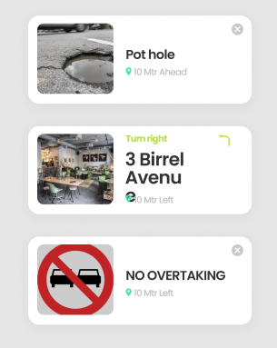

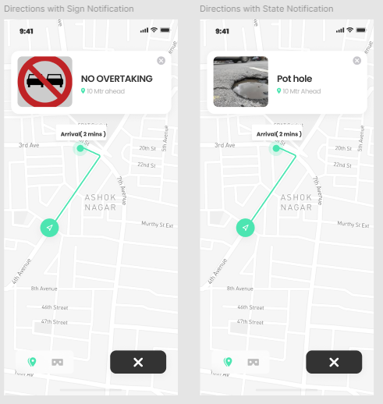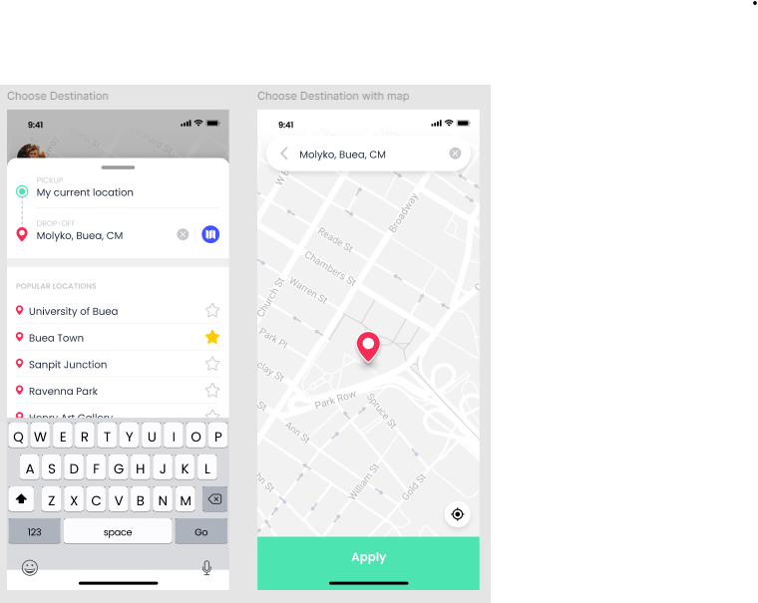

### Real-Time Sign Recognition Screen

Purpose: Displays real-time road sign recognition and alerts.

Components:

* Live Camera Feed: Shows the road ahead using the

device's camera.

* Detected Sign Display: Highlights the detected road

sign on the camera feed.

* Notification Bar: Displays real-time alerts based on

the detected sign

### User Reporting screen

Purpose: contribute to the overall road state awareness by reporting incidents or hazards they encounter on their journeys.

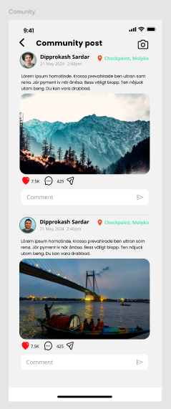Post Components:

* Event uploader
* Location
* Time and date
* Reaction
* Comment/feedback
* Send Button

### User feedback screen

Purpose: Provide feedback that could be used to enhance the application on next updates after use of application

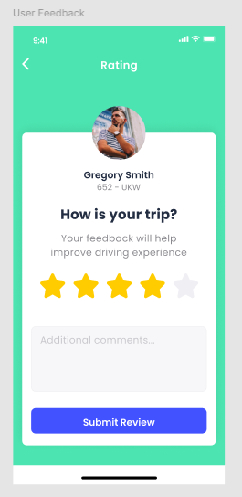Components:

* Rate stars
* Comment/feedback
* Submit review button

.

### Settings Screen

Purpose: Allows users to customize their preferences.

Components:

* Notification: Configures the types of alerts users receive and their preferred notification methods
* User Profile link and picture: takes you to user home profile where personal info is editted or costomized
* Terms and Privacy Policies: Apps terms and conditions, How user data is used
* Language Settings: Allows users to choose their preferred language for the application interface.
* Security settings: Manages data sharing and permissions for the application.

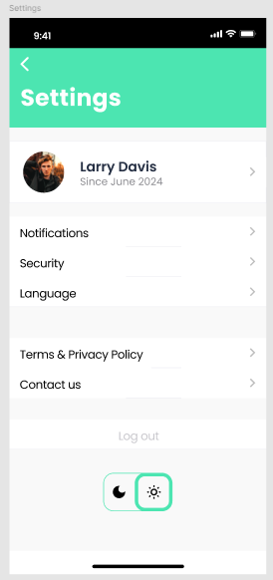

### User Profile Screen

Purpose: Allows users to manage their information and preferences.

Components:

* User Information Display: Shows the user's profile details.
* Editable Fields: Allows users to update their profile information.

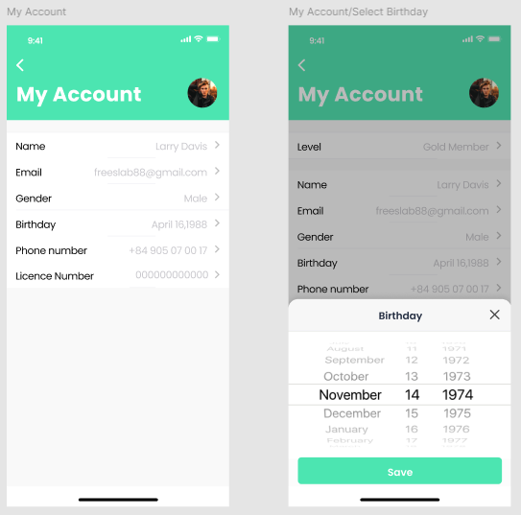Fields like drivers license are not compulsory as some users are normal pedestrians

### Help center screen

Purpose: Displays real-time alerts and notifications.

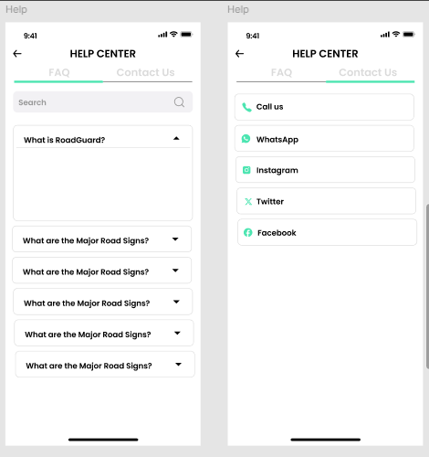Components:

* Search bar
* Contact us
* Search history

## Implementation Plan

### Frontend Technologies

* React Native: A popular framework for building cross-platform mobile applications.

## Conclusion

This document outlines the UI design and implementation plan for the Road Sign and Road State Mobile Notification Application. The design prioritizes user-friendliness and leverages HCI principles for optimal user experience. SOA principles ensure the application is modular, scalable, and maintainable. Detailed screen layouts provide clarity for development. Following this plan will result in a user-centric application that enhances driver safety and navigation.

By incorporating user feedback throughout the development process, the application can be continuously improved to meet user needs and provide a valuable tool for navigating the roads.